
Job Description

Job title | Bath Institute for the Augmented Human Manager (IAH Manager)
Department/School | Bath Institute for the Augmented Human
Job family | Research Management
Grade | 8
Reporting to | Director of the Bath Institute for the Augmented Human
Responsible for | Bath Institute for the Augmented Human Coordinator
Location | University of Bath campus (Claverton Down or Bath City sites). Applicants may be required to work flexible hours and to travel within the UK and overseas as required.

Background and context



About the Bath Institute for the Augmented Human
The Bath Institute for the Augmented Human (IAH) is the University of Bath’s newest interdisciplinary research institute, established in 2023 to position the University as a national and international leader in human augmentation research, innovation, and translation. The Institute brings together more than 80 academic members from across engineering, computer science, neuroscience, health, psychology, design, and the social sciences to address one of the most transformative technological frontiers of the 21st century.
Human augmentation – the use of advanced technologies to enhance human physical, cognitive, and sensory capabilities – is rapidly reshaping healthcare, industry, and society. Breakthroughs in neurotechnology, robotics, artificial intelligence, wearable systems, and immersive digital environments are enabling new forms of interaction between humans and machines that can improve health outcomes, enhance human performance, and transform how people live and work.
The Bath Institute for the Augmented Human has been established to accelerate innovation and translation in this rapidly emerging field. The Institute provides a platform for interdisciplinary collaboration that connects world-class academic research with industry partners, healthcare organisations, technology companies, policymakers, and user communities. Through these partnerships, the Institute aims to develop, test, and deploy new human augmentation technologies that deliver meaningful societal and economic impact.
A core focus of the Institute is to strengthen industry engagement, enterprise development, and innovation pathways, supporting the development of new technologies, spin-out opportunities, collaborative research programmes, and translational partnerships. By working closely with external partners and end users, the Institute seeks to ensure that innovations move efficiently from discovery through to real-world deployment.
The Institute is building a vibrant ecosystem that integrates research excellence, partnership, innovation, and training, supporting the development of the next generation of researchers, entrepreneurs, and innovators in human augmentation technologies. Responsible innovation and ethical deployment of technology are central to the Institute’s approach, ensuring that emerging capabilities are developed in ways that are safe, inclusive, and beneficial to society.
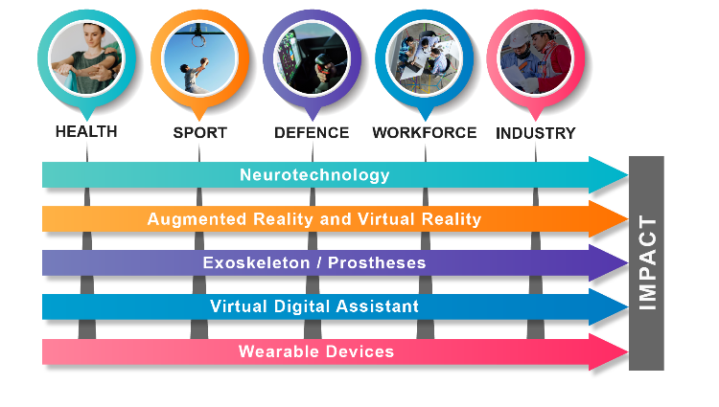
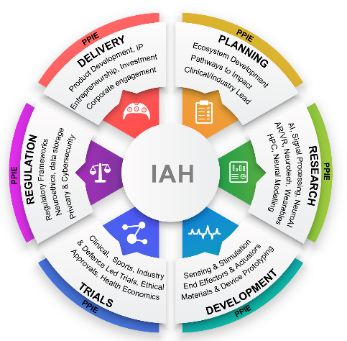
Through its interdisciplinary research community and strong external partnerships, the Bath Institute for the Augmented Human aims to establish the University of Bath as a global hub for human augmentation innovation, driving advances that improve human health, wellbeing, productivity, and quality of life.
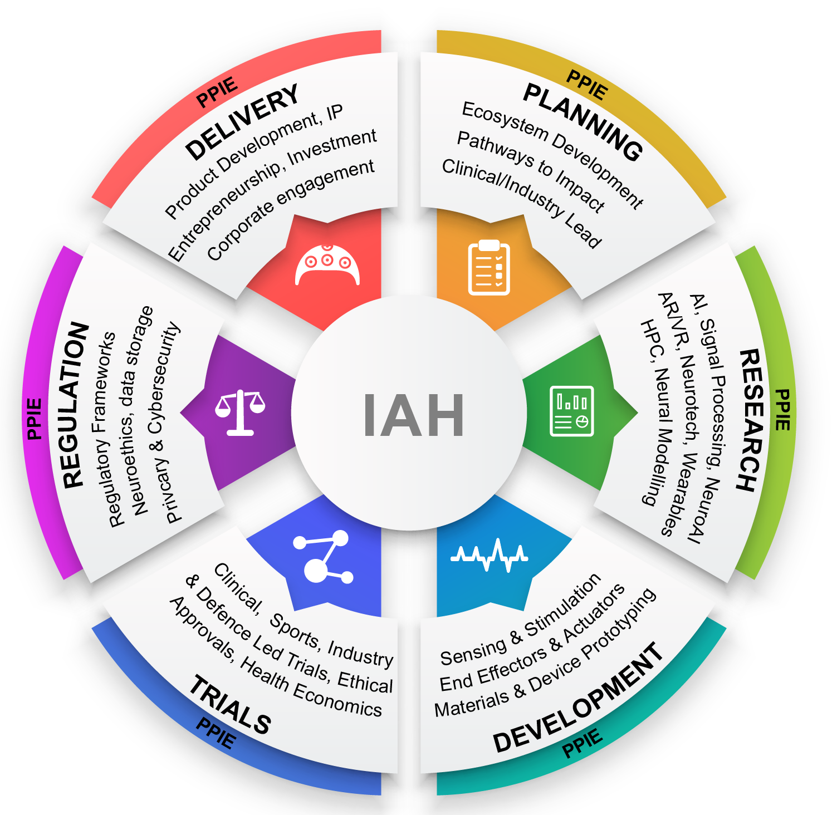

Job purpose
The Institute Manager will play a central role in the strategic development, operational delivery, and external engagement of the Bath Institute for the Augmented Human (IAH). Working closely with the Director, Deputy Directors, Research Executive, Core Team and wider Institute membership, the postholder will support the implementation of the Institute’s strategy by driving partnership development, identifying and helping to tagert new funding opportunities, and strengthening the Institute’s research, innovation, and enterprise activities.

The role will lead the coordination and delivery of the Institute’s operational and project management activities, ensuring that programmes, partnerships, and initiatives are delivered effectively and in alignment with the Institute’s strategic objectives. This includes supporting the development of sustainable funding streams, facilitating multidisciplinary collaboration across the University, and building strong relationships with industry, healthcare organisations, research partners, and other external stakeholders.

The Institute Manager will also oversee governance, reporting, and operational processes to ensure the Institute operates efficiently and in compliance with University policies and funder requirements. Acting as a key interface between academic leadership, professional services, and external partners, the postholder will help ensure the Institute maintains momentum, delivers on its targets, and continues to grow its impact nationally and internationally.

More broadly, the role will contribute to developing a vibrant innovation ecosystem around the Institute, supporting the translation of research into partnerships, collaborative programmes, and real-world applications that enhance human health, wellbeing, and performance.

The role focuses on Institute management, strategy delivery, partnerships and operational governance, and does not include responsibility for the regulatory governance of individual research projects.

The IAH Manager is line managed by the Director of the Institute. The IAH Manager will have considerable autonomy and will be expected to show substantial personal initiative.

The IAH Manager may have line management responsibilities or support line management for several key posts with the IAH Core Team to enable effective strategic partnership engagement and IAH strategy implementation.

Main duties and responsibilities

1 | Strategic Planning and Business Development & Engagement  - To contribute to the development of a grant/business development strategy of the Institute and contribute to ensuring a sustainable Business Plan is in place by the end of its initial phase of University Institute funding.  - To contribute to securing significant sustainable income for the Institute through a variety of methods, including engaging companies in long-term strategic partnerships.  - To contribute to developing an external partnerships network through establishing regular network activities, identifying strategic funding initiatives, and influencing via targeted engagement opportunities.  - To manage and develop relationships with a portfolio of individual contacts and organisations, utilising a wide range of methods; developing networks amongst contacts; and involving partners and prospects closely with planning activity within the Institute.  - To generate, manipulate and analyse information to support strategic planning and management, in order to identify new potential clients and new business needs/demands.  - To keep up to date with national and international activities in human augmentation, including the evolving funding landscape.  - To provide regular pipeline forecasts and reports to inform the University leadership team of progress, capacity planning and development priorities.  - To contribute to driving the strategic implementation of the Institute in partnership with the Directors.  - To obtain internal and external feedback, reviews and evaluation data and provide insight and recommendations to the leadership team on opportunities for improvement.  - In all the above duties the Manager should liaise with the research executive and wider membership to identify the key people so that engagements and new partners have lead academic involved and all engagement are not dependent on a single academic or director.  - The manager should be aware of skillsets and experience across the membership to build effective and sustainable partnerships.  - In agreement with Institute Directorship, the Institute Manager will lead the development and management of strategic partnerships with industry, healthcare organisations, and international collaborators, while working with the Institute Coordinator to ensure effective operational support for partner engagement activities.  - The Manager will oversee the development of partnership pipelines and opportunity tracking, supported by partnership and contact data maintained by the Institute Coordinator.
2 | Programme/Project Delivery and Management  - To work in close collaboration with the Director, Deputy Directors, Institute Coordinator, Institute Research Executive and Institute Core Team staff, Research and Innovation Services, associated departments (including Computer Science, Electrical and Electronic Engineering, Psychology, and Health) and the wider University administration to develop and promote the Institute and deliver its objectives.  - To lead in developing relationships with industry, explore a wide variety of external opportunities, leverage existing support, and create new funding streams.  - To work with the Director and Deputy Directors to discuss and agree priorities and implement the strategy as laid out in the Institute Strategy document which include a range of operational objectives and processes to be implemented.  - To be proactive in driving the expansion of the Institute’s multidisciplinary engagement and strategic partnerships.  - To monitor and contribute to achieving key delivery targets, particularly in relation to external collaboration, funding identification and creation.  - To work with the wider IAH membership and steering team to ensure projects are integrated within the Institute.  - To contribute to the development of a robust project implementation plan and lead the delivery of this plan to ensure all activities are delivered to cost, quality and time parameters and all project’s key delivery targets are met on a quarterly and yearly basis.  - To bring together institute member and other research groupings within the Institute to collaborate on project delays, finance, new opportunities, and delivery issues.  - To oversee the quality and maintenance of all project management documentation, including financial spend profiles and forecasts; risk registers; background IPR register; project plans etc.  - To lead on the development of formal reporting processes:  - Of the Institute to the University Executive Board  - Submission of annual monitoring reports and financial claims as required under its contract.  - Contribute to other initiatives to deliver policy, industry and academic research and innovation projects.
3 | Project Management and Governance and Operational Development and Delivery  - The Institute Manager will support the development and implementation of Institute-level governance structures, reporting processes, and operational policies, ensuring the Institute operates effectively and in accordance with University procedures, working with the Institute Coordinator and University professional services to ensure effective delivery of administrative, financial, governance and operational processes.  - The Institute Manager will lead the coordination and oversight of Institute programmes and strategic initiatives, ensuring delivery against agreed objectives, timelines and funding requirements, and working closely with the Institute Coordinator who provides administrative and operational support.  - To assist in project management and the day-to-day work of the team of IAH Core Team and technical support.  - To develop and maintain processes for capturing and recording data relating to contacts and partnerships.  - To ensure compliance with University contractual requirements and internal financial processes.  - Develop and lead the professional service performance and delivery of the Institute, including financial, legal, resourcing and benefits delivery.  - Work collaboratively with key stakeholders, develop systems, information and processes for effective management, governance, and assurance to develop and sustain the Institute.  - To provide strategic oversight of the Institute’s financial management, including monitoring financial performance, reviewing budget forecasts, and ensuring resources are aligned with the Institute’s strategic priorities. The Manager will work closely with the Institute Coordinator and University Finance teams who are responsible for day-to-day financial administration including the regular formal financial and progress reporting against agreed requirements and metrics to funders.  - To present at high-profile meetings and/or external forums as relevant to support the communications and engagement activities of the Institute  - To lead on engagement and collaboration with professional services teams within the University e.g., Finance, Legal, HR, Research Services and Academic Departments on behalf of the Institute to ensure seamless operational delivery between the Institute and its external partners.  - To deputise for the Director / Deputy Director as appropriate.  - To oversee compliance with University governance and policy and support the Academic Directors in delivering the institutes strategic objectives.  - The role relates specifically to the governance and operational management of the Institute as an organisational entity and does not include responsibility for research governance approvals (e.g., ethics approvals, regulatory compliance, or clinical governance), which remain the responsibility of individual Principal Investigators, Departments, and the University’s formal research governance processes.  - Maintain a working awareness of University research governance requirements and direct Institute members to the appropriate University services (e.g., Research Governance, Ethics Committees, or Regulatory Support teams) where relevant. Responsibility for obtaining and managing research governance approvals remains with individual investigators and their host departments.  - To support the development of patient and public involvement and engagement activities in collaboration with the Institute Coordinator, Institute Core Team and Research Executive
4 | Communications  - The Institute Manager will lead the strategic development of external engagement activities, including identifying opportunities for industry engagement, partnership development and strategic events.  - To provide written and verbal updates to the Institute’s Director, Deputy Directors, and Management Board, Steering Group and Management Board, as required.  - To create influence and impact internal and external to the University, including presenting and disseminating information on Institute activities to a variety of groups and audiences.  - To work closely with the Institute Coordinator on Marketing and Communications to ensure effective and appropriate external communications.  - To promote IAH across the UK and Internationally.
5 | The Institute Manager will from time to time be required to undertake other duties of a similar nature as reasonably required by Institute Director and/or Deputy Director.

Person Specification

Criteria | Essential | Desirable
Qualifications
An undergraduate and/or Masters degree | ✓
A PhD degree in subject area of direct relevance for the project, or equivalent significant relevant experience and professional qualification |  | ✓
A project management qualification |  | ✓
Experience/Knowledge

Familiarity with the technologies associated with human augmentation and their applications |  | ✓
Project management experience | ✓
Experience in delivering collaborative projects between academic organisations and/ business | ✓
An understanding of research funding opportunities |  | ✓
Experience of line management | ✓
Experience of coordinating work across internal and external teams | ✓
Skills
Experience of producing written documents materials to a high standard. A high level of literacy and ability to draft briefing papers for senior colleagues | ✓
An understanding of mechanisms for corporate engagement with universities, including contract development |  | ✓
Experience of public speaking and giving presentations to a variety of audiences | ✓
Experience of working with a diverse range of colleagues within a large and complex organisation |  | ✓
Ability to organise and prioritise own and others’ workloads | ✓
Attributes
Versatile, innovative and developing creative solutions | ✓
Ability to be an effective interdisciplinary team worker | ✓
Commitment to safe working practices | ✓
Commitment to working within professional and ethical codes of conduct | ✓
Commitment to collaborative and interdisciplinary engagement | ✓

Effective Behaviours Framework

The University has identified a set of effective behaviours which we value and have found to be consistent with high performance across the organisation. Part of the selection process for this post will be to assess whether candidates have demonstrably exhibited these behaviours previously.

Managing self and personal skills:
Willing and able to assess and apply own skills, abilities and experience. Being aware of own behaviour and how it impacts on others.

Delivering excellent service:
Providing the best quality service to all students and staff and to external customers e.g. clients, suppliers. Building genuine and open long-term relationships in order to drive up service standards.

Finding innovative solutions:
Taking a holistic view and working enthusiastically and with creativity to analyse problems and develop innovative and workable solutions. Identifying opportunities for innovation.

Embracing change:
Adjusting to unfamiliar situations, demands and changing roles. Seeing change as an opportunity and being receptive to new ideas.

Using resources:
Making effective use of available resources including people, information, networks and budgets. Being aware of the financial and commercial aspects of the University.

Engaging with the big picture:
Seeing the work that you do in the context of the bigger picture e.g. in the context of what the University/other departments are striving to achieve and taking a long-term view. Communicating vision clearly and enthusiastically to inspire and motivate others.

Developing self and others:
Showing commitment to own development and supporting and encouraging others to develop their knowledge, skills and behaviours to enable them to reach their full potential for the wider benefit of the University.

Working with people:
Working co-operatively with others in order to achieve objectives. Demonstrating a commitment to diversity and applying a wider range of interpersonal skills.

Achieving results:
Planning and organising workloads to ensure that deadlines are met within resource constraints. Consistently meeting objectives and success criteria.

